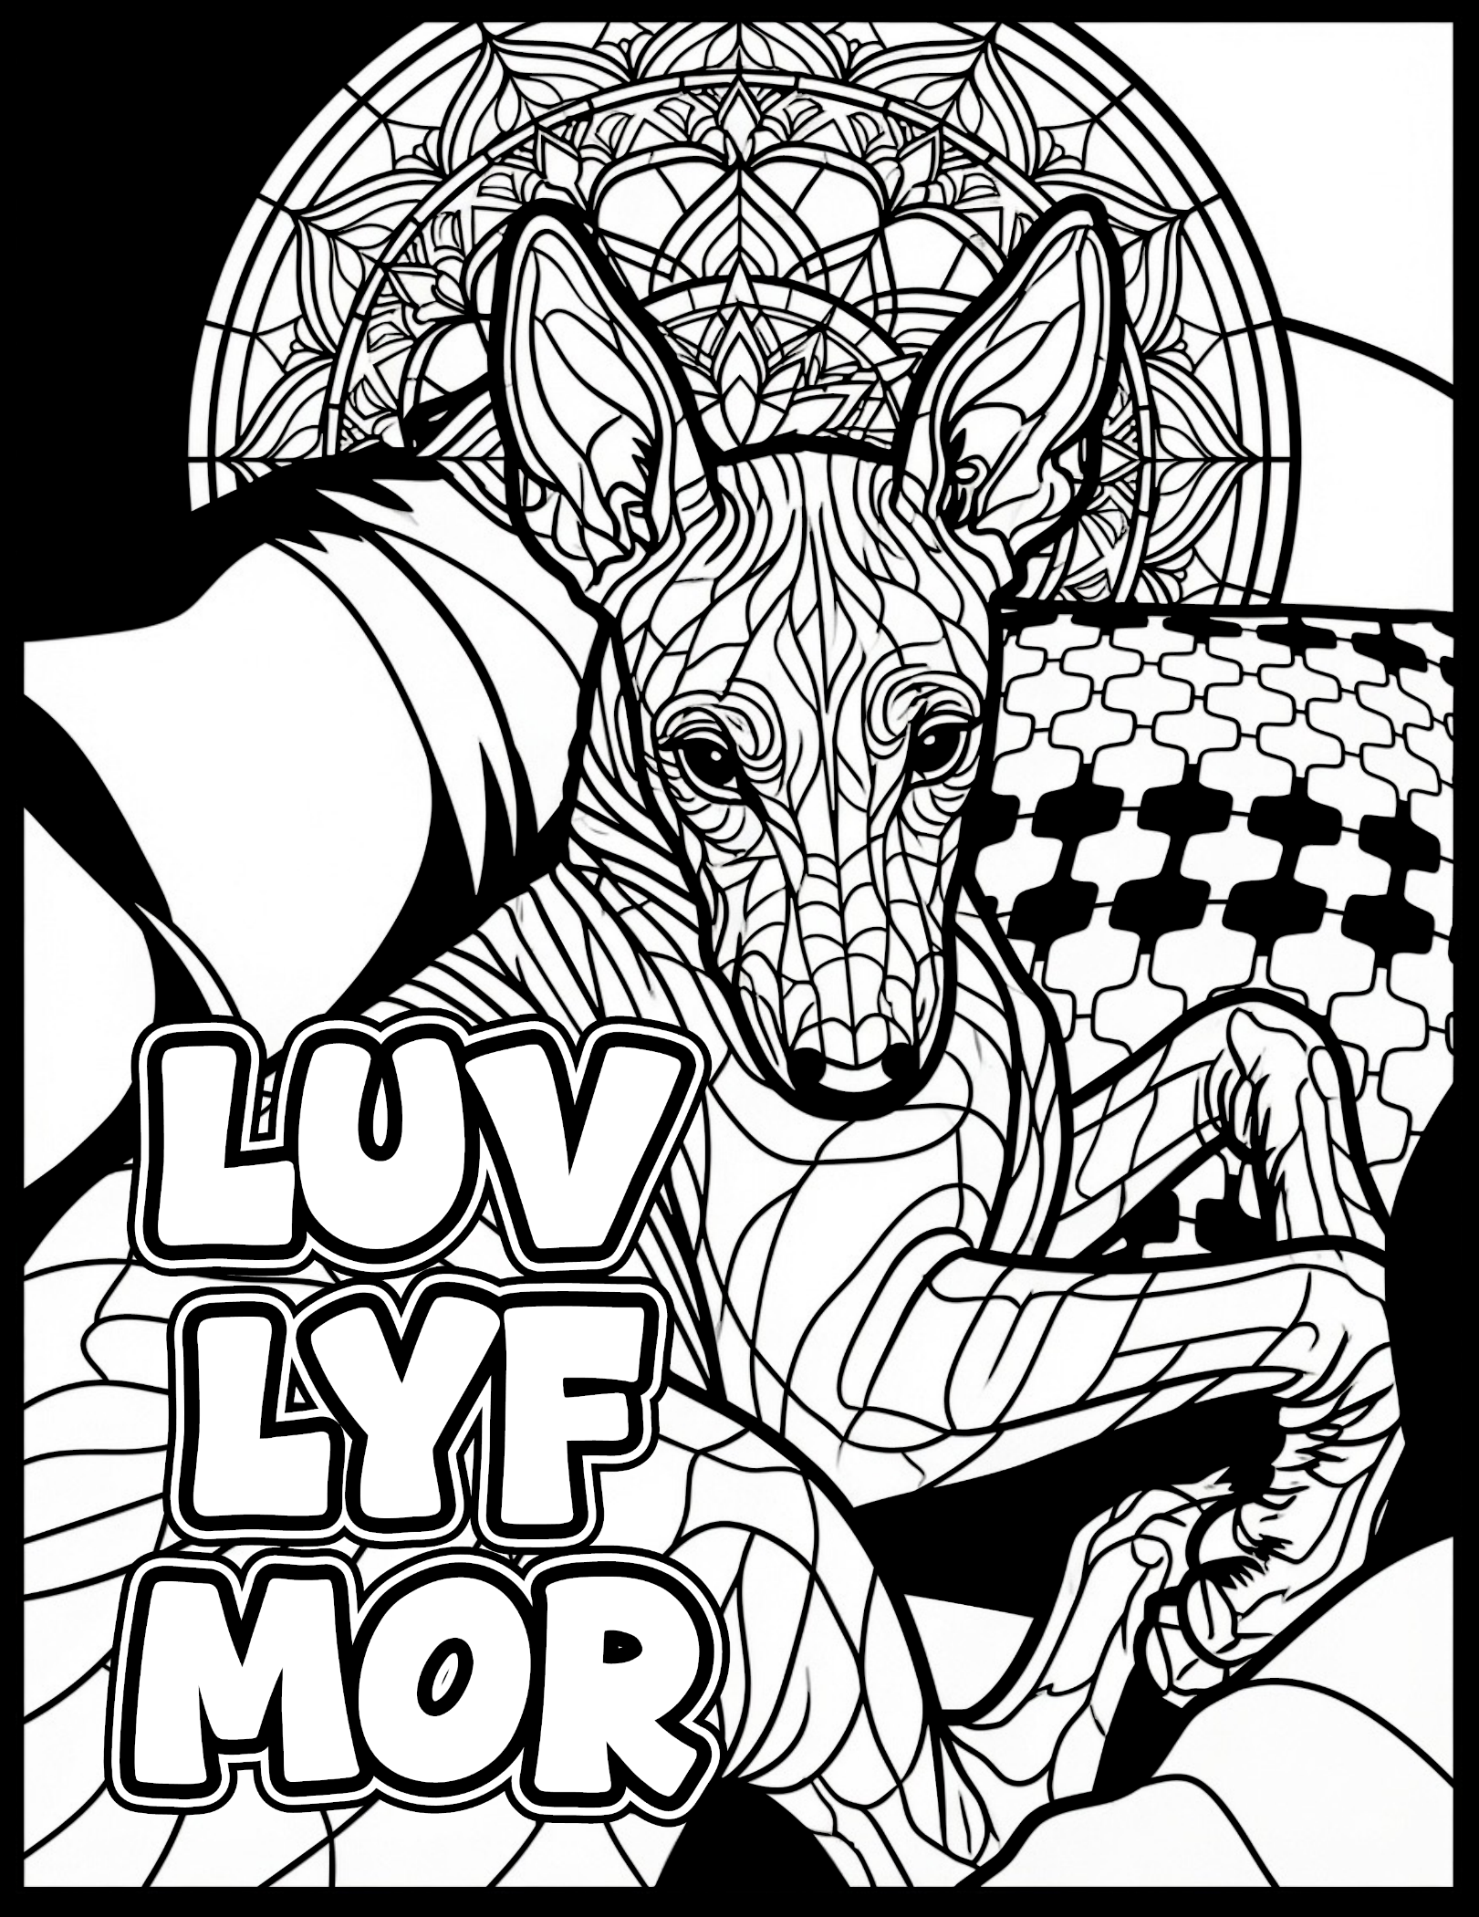
Chapter 1: LUV LYF MOR – May this art reach you in ways that long chapters could never do.
Loving life more is the answer, having fun is how to make it come true.
If you downloaded this free adult coloring page, please help us reach our goal of having this coloring book hit the BEST SELLERS LIST! Proceeds go to help fund Nate’s Glow Search and Rescue.
Go to www.LUVLYFMOR.com to help us reach the goal!

